UpTrend: A Structured Educational and Behavioural Framework for Improving Decision-Making in Beginner Retail Traders
Abstract
The rapid growth of retail participation in financial markets has led to an increasing number of beginner traders entering trading environments without adequate knowledge, structured guidance, or psychological preparedness. Studies in behavioural finance indicate that emotional decision-making, cognitive biases, and lack of systematic learning are primary contributors to consistent losses among novice traders. Existing trading platforms primarily focus on execution rather than education and behavioural correction.
This paper proposes UpTrend, a structured educational and behavioural framework designed specifically to improve the decision-making quality of beginner retail traders. The system integrates modular learning, interactive knowledge reinforcement, psychological awareness, and guided trading practices into a single platform. Unlike conventional trading applications, UpTrend emphasizes learning progression, behavioural discipline, and practical simulation before real-market exposure.
The proposed framework combines educational technology principles with behavioural finance insights to create a learning-to-execution pipeline for novice traders. This paper presents the architecture, methodology, and expected impact of the UpTrend model in addressing the critical gap between trading access and trading preparedness.
Unlike fragmented learning resources and execution-focused trading platforms, UpTrend introduces the first integrated preparatory pipeline that embeds behavioural awareness directly into progressive trading education and guided practice.
Keywords
Retail Trading, behavioural Finance, Financial Literacy, Educational Technology, Decision-Making Systems, Beginner Traders, Learning Framework, Trading Psychology
I. Introduction
The last decade has witnessed an unprecedented rise in retail participation in financial markets, driven by the proliferation of online trading platforms, mobile accessibility, and social media–influenced financial awareness. Individuals with little to no formal financial education are now actively engaging in equity, derivatives, and cryptocurrency markets. While access to markets has become easier than ever, preparedness for trading has not evolved at the same pace.
A significant proportion of beginner retail traders experience consistent financial losses within their initial months of trading. Research in behavioural finance attributes this trend not merely to lack of market knowledge but to cognitive biases, emotional decision-making, overconfidence, fear-driven exits, and absence of structured learning pathways. Most existing trading platforms prioritize trade execution, charting tools, and speed, while offering minimal emphasis on educating users about disciplined decision-making or psychological preparedness.
This mismatch between accessibility and preparedness has created a critical gap in the retail trading ecosystem. Beginners are exposed to high-risk environments without undergoing structured training, behavioural conditioning, or guided practice. As a result, trading becomes a process of trial and error rather than informed decision-making.
Educational technology has successfully transformed learning in various domains by introducing modular learning, interactive reinforcement, and progress tracking. However, such principles are rarely integrated into trading environments. There exists a need for a system that bridges financial education, behavioural awareness, and practical execution into a single structured framework.
This paper proposes UpTrend, a structured educational and behavioural framework specifically designed to improve decision-making quality among beginner retail traders. UpTrend integrates modular learning, interactive knowledge checks, psychological awareness mechanisms, and guided trading simulations to create a learning-to-execution pipeline. The system aims to transform how beginners approach trading—from impulsive participation to informed and disciplined decision-making.
The remainder of this paper presents the theoretical foundations, system architecture, learning model, behavioural intervention strategies, and expected impact of the UpTrend framework in addressing the critical shortcomings of current retail trading platforms.
A. Contributions of This Paper
This paper makes the following key contributions:
- Proposes UpTrend, a novel preparatory framework that integrates structured financial learning with behavioural conditioning before live market participation.
- Bridges gaps between financial education, behavioural finance, and decision support systems into a single learning-to-practice pipeline.
- Introduces a layered architecture that transforms beginner traders into decision-ready participants through guided practice and feedback loops.
- Presents a measurable evaluation model to assess improvement in decision consistency and risk discipline among novice traders.
II. Literature Review
The challenges faced by beginner retail traders have been widely discussed across research in behavioural finance, financial literacy, and decision sciences. Empirical studies consistently show that novice participants in financial markets underperform not only due to lack of technical knowledge but also due to psychological and cognitive limitations that affect their decision-making processes.
Behavioural finance research pioneered by Daniel Kahneman and Amos Tversky introduced the concept of cognitive biases in financial decisions. Their Prospect Theory explains how individuals tend to exhibit loss aversion, overreact to short-term market fluctuations, and make irrational choices under uncertainty. These biases are particularly prominent among beginner traders who lack experience and structured guidance.
Further studies by Richard Thaler highlight how mental accounting, overconfidence, and herd behaviour significantly influence retail investor actions. Beginner traders often follow social media trends, tips, and crowd sentiment rather than systematic analysis, leading to inconsistent outcomes and amplified risk exposure.
Research on retail trading performance (e.g., studies by Brad M. Barber and Terrance Odean) shows that frequent trading, emotional reactions, and overestimation of personal skill contribute to sustained losses among individual investors. Their findings demonstrate that individuals who trade more frequently tend to earn lower net returns due to poor timing and impulsive decisions.
In parallel, studies in financial literacy emphasize that access to financial markets has grown faster than access to structured financial education. Research by Annamaria Lusardi indicates that a majority of retail participants lack foundational understanding of risk management, compounding, and market mechanisms. This gap becomes critical when individuals engage in leveraged or derivative trading without sufficient preparation.
From an educational technology perspective, modular learning, interactive assessments, and progress tracking have proven effective in improving retention and behavioural change across disciplines. However, trading platforms rarely integrate these principles into their user experience. Most applications assume users already possess the required discipline and knowledge, offering tools for execution rather than structured preparation.
Additionally, research in decision support systems suggests that guided workflows and structured environments significantly enhance decision quality for novices in complex domains. Trading, being a high-uncertainty and high-risk domain, fits this category, yet lacks systems that provide decision scaffolding for beginners.
Existing trading education is often fragmented—spread across online videos, courses, blogs, and social communities. This unstructured approach forces beginners to self-curate their learning journey, which frequently results in misinformation, incomplete understanding, and lack of behavioural discipline.
The literature therefore highlights three consistent gaps:
- Cognitive and emotional biases heavily affect beginner traders.
- Financial literacy among retail participants is insufficient for market participation.
- Trading platforms do not integrate structured learning and behavioural correction into their systems.
These gaps motivate the need for a unified framework that combines financial education, behavioural awareness, and practical trading guidance. The proposed UpTrend framework is designed specifically to address these shortcomings by embedding educational and psychological reinforcement directly into the trading preparation process.
III. Problem Statement
The rapid democratization of financial markets through digital trading platforms has enabled widespread participation from individuals with minimal prior exposure to financial education or trading discipline. While accessibility has increased, there is a critical absence of structured systems that prepare beginners for the cognitive, educational, and behavioural demands of trading.
Existing trading platforms primarily focus on order execution, technical charting, and market data visualization. These tools assume that users already possess adequate knowledge of risk management, trading psychology, and decision-making discipline. However, empirical evidence from behavioural finance and investor performance studies indicates that beginner traders lack these foundational capabilities, resulting in emotionally driven decisions, overtrading, poor risk assessment, and consistent financial losses.
Simultaneously, trading education available to beginners is highly fragmented. Learning resources are dispersed across videos, blogs, social media content, and paid courses without a guided pathway, progress monitoring, or behavioural reinforcement. Beginners are required to self-navigate complex information ecosystems without understanding how to translate knowledge into disciplined market behaviour.
This disconnect creates a fundamental problem:
There is no integrated system that combines structured financial education, behavioural awareness, and guided practical preparation for beginner retail traders before they engage in live markets.
As a result, beginners enter high-risk trading environments without:
- Understanding cognitive biases that affect their decisions,
- Developing disciplined trading habits,
- Practicing structured decision-making in a guided setting,
- Receiving feedback on their learning progression.
The absence of such a framework leads to trial-and-error learning directly in live markets, which is financially and psychologically costly.
Therefore, the core problem addressed in this paper is:
How can a structured educational and behavioural framework be designed to improve the decision-making quality of beginner retail traders before and during their participation in financial markets?
The UpTrend model is proposed as a solution to this problem by integrating modular learning, interactive reinforcement, behavioural conditioning, and guided trading preparation into a single cohesive system.
IV. Conceptual Foundation
The design of the UpTrend framework is grounded in three major theoretical domains: behavioural finance, educational technology, and decision support systems. These domains collectively explain why beginner traders struggle in financial markets and how a structured system can improve their decision-making capabilities.
A. Behavioural Finance and Cognitive Biases
Behavioural finance explains how psychological factors influence financial decisions under uncertainty. Foundational work by Daniel Kahneman and Amos Tversky demonstrates that individuals rely on heuristics that often lead to systematic errors in judgment. Prospect Theory shows that individuals exhibit loss aversion, where the fear of losses outweighs the rational assessment of gains. This leads beginner traders to exit profitable trades prematurely and hold losing positions longer than advisable.
Additional cognitive biases particularly relevant to retail trading include:
- Overconfidence bias – overestimating one’s market understanding after limited success,
- Herd behaviour – following social sentiment rather than analysis,
- Recency bias – making decisions based on recent market movements,
- Confirmation bias – seeking information that supports pre-existing beliefs.
These biases are amplified in beginners due to lack of experience and absence of structured guidance. Therefore, any system aimed at improving trading outcomes must incorporate mechanisms that address psychological behaviour, not just technical knowledge.
B. Educational Technology and Structured Learning
Research in educational technology shows that learning outcomes improve when content is delivered through modular structures, interactive assessments, and progress tracking. Micro-learning techniques enhance retention by breaking complex topics into smaller, manageable units. Interactive questioning and reinforcement improve understanding and long-term recall.
Trading education available today rarely follows these principles. Beginners consume long-form, unstructured content without checkpoints to verify understanding or systems to monitor learning progression. UpTrend adopts educational technology principles to convert trading education into a structured, trackable learning pathway.
C. Decision Support Systems for Novices
Decision support systems (DSS) are designed to assist individuals in making better decisions in complex environments by providing structured workflows and guidance. Trading is inherently a high-uncertainty, high-risk environment requiring disciplined decision processes. However, current platforms provide tools without guidance, assuming users know how to interpret information correctly.
By embedding guided workflows and structured preparation before real trading exposure, a DSS-inspired approach can significantly enhance decision quality for beginners.
By combining these three theoretical foundations, the UpTrend framework positions itself not as a trading platform, but as a decision-preparation system. It addresses:
- Psychological readiness through behavioural awareness,
- Knowledge readiness through structured learning,
- Practical readiness through guided preparation.
This integrated conceptual base differentiates UpTrend from traditional trading or educational applications and forms the academic basis for the proposed system.
V. The UpTrend Framework
The UpTrend framework is designed as an integrated educational and behavioural preparation system for beginner retail traders. Unlike conventional trading applications that emphasize market access and execution tools, UpTrend prioritizes decision readiness before market participation. The framework introduces a structured pathway that guides users from foundational learning to psychologically disciplined trading preparation.
At its core, UpTrend operates on the principle that effective trading is not merely a function of market knowledge, but a combination of education, behavioural discipline, and guided practice. The framework organizes these components into a cohesive flow that ensures beginners do not directly engage in live markets without undergoing systematic preparation.
A. Framework Philosophy
The philosophy of UpTrend is based on three sequential stages:
- Learn – Acquire structured knowledge about markets, risk, and trading principles.
- Internalize – Understand personal cognitive biases and psychological tendencies.
- Prepare – Practice decision-making in a guided environment before live execution.
This progression ensures that learning is translated into behavioural readiness rather than remaining theoretical.
B. Core Components of the Framework
The UpTrend framework consists of the following interconnected components:
- Structured Learning Modules (Academy)
Modular content designed like a guided book, divided into progressive topics with embedded interactive questions and reinforcement checks.
- Behavioural Awareness Layer
Mechanisms that educate users about cognitive biases, emotional triggers, and disciplined trading habits.
- Guided Practice Environment
A simulated or controlled environment where users apply learned concepts before participating in real markets.
- Progress Tracking and Feedback
Continuous monitoring of user learning progression and preparedness indicators.
These components work together to create a pipeline where education, psychology, and practice are not separate activities but parts of a unified system.
C. Framework Objective
The primary objective of the UpTrend framework is:
To improve the decision-making quality of beginner retail traders by ensuring structured learning, behavioural conditioning, and guided preparation prior to live market exposure.
By structuring the trading preparation journey, UpTrend aims to reduce impulsive decision-making, overtrading, and emotionally driven actions that commonly result in losses among beginners.
D. Differentiation from Existing Systems
Traditional trading platforms provide tools for analysis and execution. Educational platforms provide theoretical knowledge. UpTrend bridges this gap by embedding education and behavioural reinforcement directly into the preparation process for trading.
This integration transforms trading preparation from an unstructured self-learning process into a guided, measurable, and psychologically informed pathway.

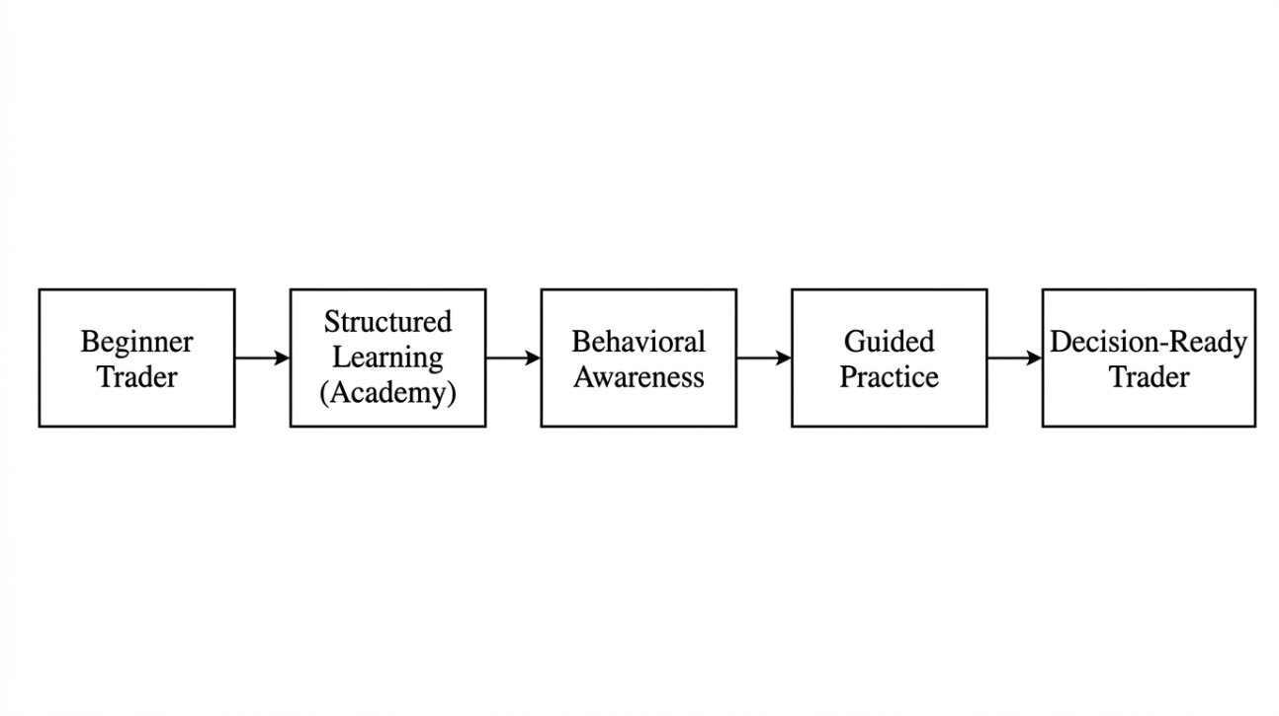
Fig. 1. Overall UpTrend Framework Flow

VI. System Architecture of UpTrend
The UpTrend system architecture is designed to operationalize the educational and behavioural framework into a functional, user-centered platform. The architecture connects learning, behavioural awareness, guided practice, and progress tracking into a continuous flow that supports decision readiness for beginner traders.
Rather than functioning as a conventional trading interface, UpTrend acts as a preparatory layer that users pass through before engaging in live markets. The system architecture ensures that each component of learning and behavioural conditioning is structurally linked to the user’s progression.
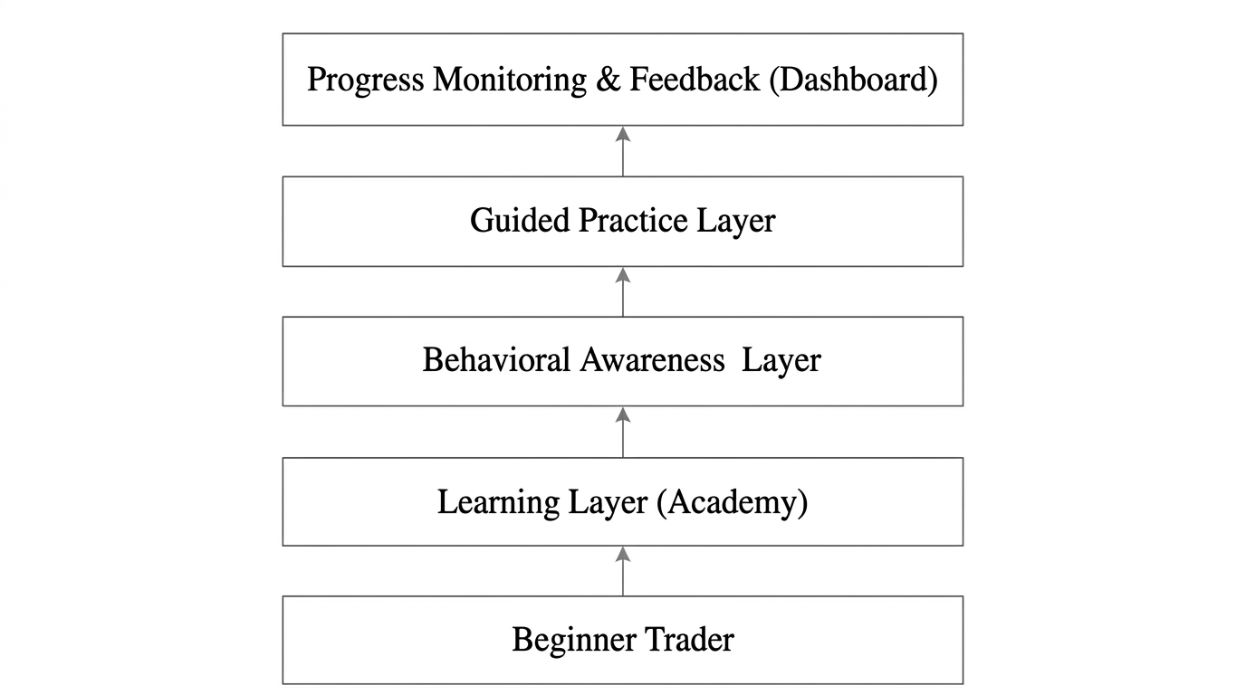
Fig. 2. Layered System Architecture of UpTrend
A. Architectural Overview
The architecture consists of four primary layers:
- Learning Layer (Academy)
- Behavioural Awareness Layer
- Guided Practice Layer
- Progress Monitoring and Feedback Layer (Dashboard)
These layers interact sequentially and cyclically, forming a learning-to-preparation loop.
B. Learning Layer – Academy
The Academy serves as the foundational entry point for users. It delivers modular content structured into progressive topics such as market basics, risk management, trading strategies, and trading psychology. Each module includes short conceptual explanations followed by interactive questions that reinforce understanding.
This layer ensures that users build conceptual clarity before advancing further in the system.
C. Behavioural Awareness Layer
Integrated within the learning process are behavioural checkpoints that educate users about cognitive biases and emotional trading tendencies. Users are made aware of how fear, greed, overconfidence, and herd behaviour affect trading decisions.
This layer is not separate from learning but embedded within modules to promote psychological awareness alongside technical understanding.
D. Guided Practice Layer
After completing learning segments, users enter a guided practice environment where they apply concepts in simulated or controlled scenarios. This stage enables users to practice structured decision-making without financial risk.
The purpose of this layer is to convert theoretical knowledge into disciplined action patterns.
E. Progress Monitoring and Feedback Layer – Dashboard
The dashboard tracks user progression across modules, behavioural understanding, and practice performance. It provides feedback on readiness levels and highlights areas requiring improvement.
This continuous monitoring ensures that users do not advance prematurely without adequate preparation.
F. Architectural Flow
The system follows this flow:
Learn → Understand Behaviour → Practice Decisions → Receive Feedback → Improve → Repeat
This cyclical structure ensures reinforcement of knowledge and behaviour over time.
VII. Learning Model Design in UpTrend
The effectiveness of UpTrend depends heavily on how trading knowledge is structured and delivered to beginners. Traditional trading education is often delivered through long-form videos, articles, or unstructured courses that lack progression control and understanding verification. UpTrend addresses this limitation by adopting a modular micro-learning model inspired by principles of educational technology.
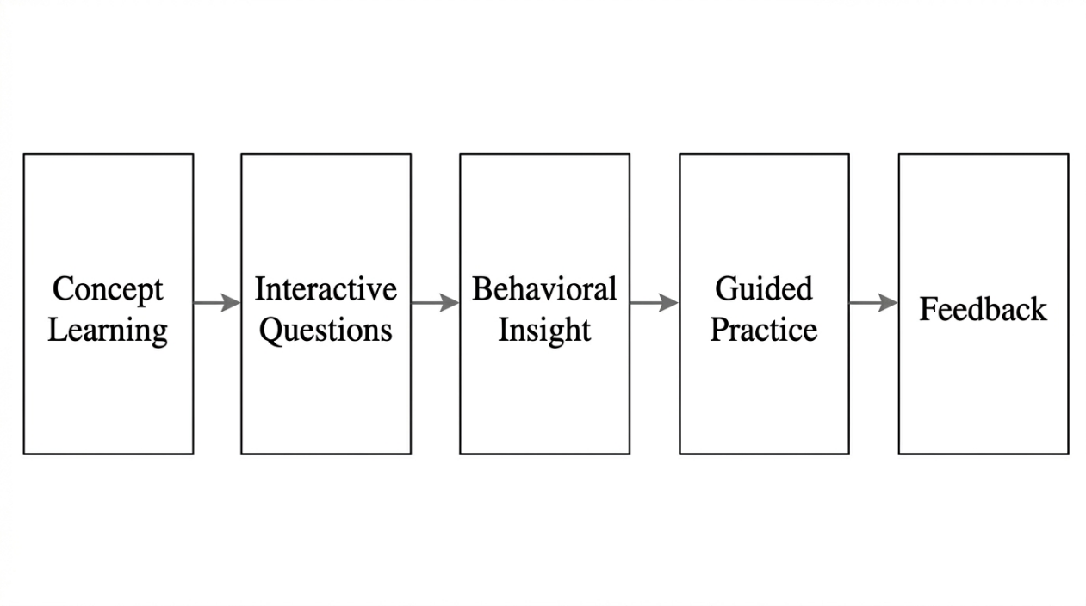
Fig. 3. Learning-to-Execution Pipeline in UpTrend
A. Modular Micro-Learning Structure
The Academy in UpTrend divides trading education into small, logically sequenced modules. Each module focuses on a single concept such as:
- Market fundamentals
- Risk and reward principles
- Position sizing
- Trading strategies
- Trading psychology
This micro-learning approach prevents cognitive overload and improves retention among beginners.
B. Interactive Reinforcement
After each concept, users encounter interactive questions designed to test comprehension before moving forward. These are not evaluative exams but reinforcement checkpoints that ensure understanding.
This transforms passive learning into active engagement.
C. Progressive Learning Path
Users cannot skip ahead arbitrarily. The system enforces a progression where foundational topics must be completed before advanced topics are unlocked. This ensures conceptual continuity and disciplined learning behaviour.
D. Learning-to-Application Transition
A key feature of the learning model is that modules are directly connected to practice scenarios. After learning a concept (e.g., risk management), users immediately apply it in guided practice environments.
This bridges the gap between theoretical knowledge and practical decision-making.
VIII. Behavioural Intervention Model
A distinguishing aspect of the UpTrend framework is its explicit focus on behavioural correction alongside educational delivery. While most trading platforms assume rational decision-making from users, research in behavioural finance demonstrates that trading decisions are often driven by emotional and cognitive biases rather than logical analysis. UpTrend addresses this challenge by embedding behavioural intervention mechanisms directly into the learning and practice process.
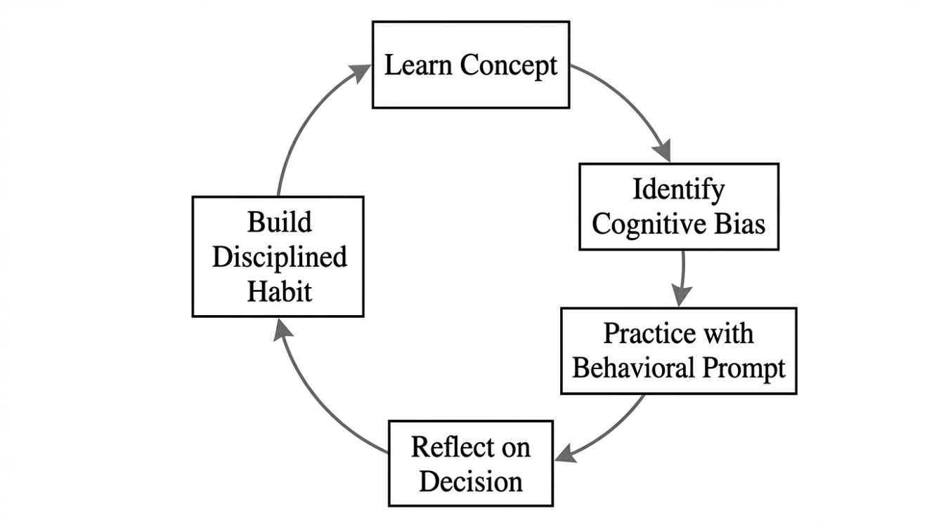
Fig. 4. Behavioural Intervention Flow in UpTrend
A. Identification of Key Behavioural Risks
Beginner traders are particularly vulnerable to predictable psychological patterns, including:
- Fear-driven exits during minor market fluctuations,
- Greed-driven overtrading after small gains,
- Overconfidence following short-term success,
- Impulsive decisions influenced by social sentiment,
- Holding losing positions due to loss aversion.
These patterns align with the cognitive biases identified by Daniel Kahneman and Amos Tversky in Prospect Theory and subsequent behavioural research.
B. Embedded Behavioural Awareness
UpTrend does not treat psychology as a separate topic but integrates behavioural insights within learning modules. For example, while teaching risk management, users are simultaneously informed about loss aversion and emotional tolerance to drawdowns. This contextual delivery improves self-awareness during decision-making.
C. Behavioural Prompts During Practice
During guided practice sessions, users encounter prompts that encourage reflection before taking decisions. These prompts simulate real trading pressure and ask users to justify their actions based on learned principles rather than emotions.
D. Habit Formation Through Repetition
The cyclical structure of learning, practice, and feedback encourages habit formation. By repeatedly applying disciplined decision steps in a controlled environment, users develop structured trading habits that can transfer to real-market participation.
E. Objective of Behavioural Intervention
The goal is not to eliminate emotions but to help users recognize and manage them. By increasing awareness and reinforcing disciplined actions, UpTrend aims to reduce emotionally driven trading behaviour among beginners.
IX. Methodology: How UpTrend Improves Decision-Making Quality
This section describes the methodological approach through which the UpTrend framework enhances the decision-making capabilities of beginner retail traders. The methodology is based on guiding users through a structured pathway where learning, behavioural awareness, and practical application collectively improve decision quality over time.
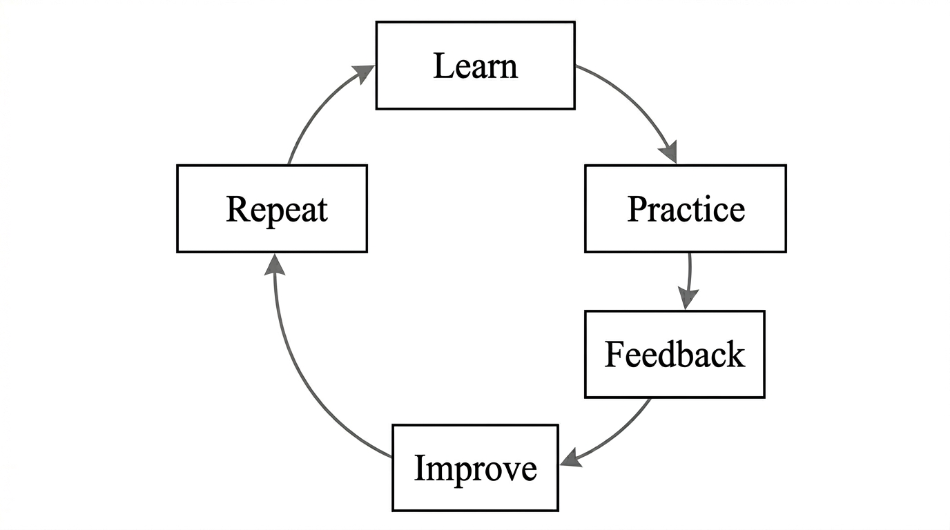
Fig. 5. User Progress and Feedback Loop
A. Decision-Making as a Measurable Outcome
In the context of trading, decision quality can be evaluated through indicators such as:
- Adherence to risk management principles,
- Reduction in impulsive trading actions,
- Consistency in applying learned strategies,
- Ability to justify trade decisions logically,
- Reduced influence of emotional reactions during simulated scenarios.
UpTrend is designed to influence these indicators through its structured system.
B. Sequential User Journey
The methodology follows a defined user journey:
- Concept Acquisition through modular learning,
- Bias Awareness integrated within lessons,
- Guided Application in practice environments,
- Feedback and Reflection via dashboard tracking,
- Reinforcement through repeated cycles.
This sequence ensures that knowledge is converted into disciplined decision behaviour rather than remaining theoretical.
C. Feedback-Driven Improvement
The dashboard continuously tracks user progress across learning modules and practice sessions. Users receive feedback on areas where their decisions deviate from recommended principles, enabling targeted improvement.
D. Reduction of Trial-and-Error in Live Markets
By shifting early mistakes into a simulated and guided environment, UpTrend reduces the need for financially costly trial-and-error learning in real markets.
E. Expected Behavioural Shift
Over repeated cycles, users are expected to:
- Develop structured decision routines,
- Improve patience and discipline,
- Demonstrate increased awareness of cognitive biases,
- Apply risk management more consistently.
X. Expected Outcomes and Evaluation Plan
This section outlines the anticipated impact of the UpTrend framework and proposes an evaluation approach to measure its effectiveness in improving decision-making quality among beginner retail traders.
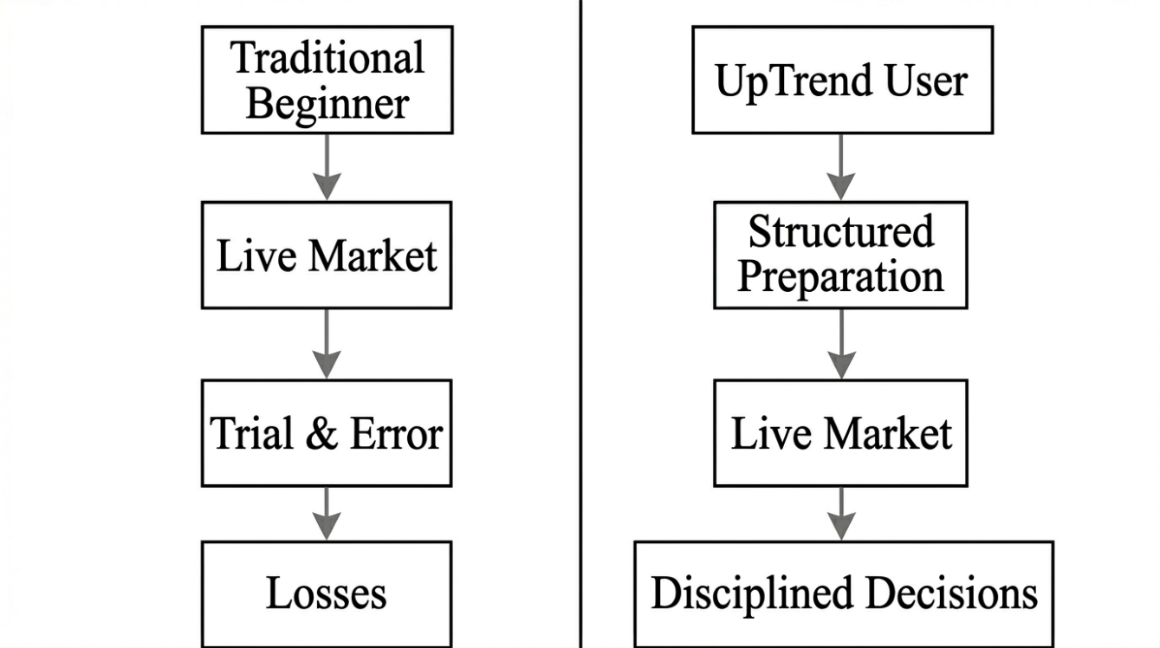
Fig. 6. Proposed Evaluation Model for UpTrend
A. Expected Outcomes
Based on the integration of educational structure and behavioural intervention, the following outcomes are expected for users of UpTrend:
- Improved understanding of market fundamentals and risk management principles.
- Increased awareness of cognitive biases affecting trading decisions.
- Reduction in impulsive and emotionally driven trading behaviour.
- Greater consistency in applying structured trading strategies.
- Enhanced confidence derived from preparation rather than guesswork.
These outcomes collectively contribute to improved decision quality before users participate in live markets.
B. Evaluation Metrics
The effectiveness of UpTrend can be evaluated using measurable indicators collected during user interaction with the system:
- Completion rate of learning modules,
- Accuracy in interactive reinforcement questions,
- Performance in guided practice scenarios,
- Frequency of emotionally inconsistent decisions during simulations,
- Improvement trends observed through dashboard feedback data.
These metrics provide quantifiable evidence of user progression in both knowledge and behaviour.
To operationalize decision quality, this paper proposes a composite indicator termed the Decision Discipline Score (DDS). The DDS can be calculated from user interactions during guided practice sessions by measuring adherence to predefined risk management rules, consistency of responses across emotionally varied scenarios, and reduction in impulsive decision patterns over repeated cycles. Each practice scenario can be scored based on whether the user follows structured decision principles taught in the learning modules. Over time, trends in DDS values can indicate improvement in disciplined decision-making. This metric allows an objective comparison between users who undergo traditional unstructured learning and those who complete the UpTrend preparation framework, without requiring live market data.
C. Proposed Evaluation Method
A potential evaluation study could involve two groups of beginner traders:
- A control group using conventional learning resources and direct market participation,
- An experimental group using the UpTrend framework before market participation.
Decision-making quality, risk adherence, and behavioural consistency can be compared across both groups over a defined period.
D. Long-Term Impact
If validated through practical implementation, UpTrend has the potential to:
- Reduce early-stage losses among beginner traders,
- Promote disciplined trading culture,
- Serve as a preparatory standard before live trading access.
XI. Future Scope
The UpTrend framework, as proposed in this paper, represents an initial model for integrating structured education and behavioral intervention into trading preparation. However, the concept can be extended and refined through further research and technological enhancements.
A. Integration with Live Trading Platforms
Future implementations of UpTrend can be integrated directly with live trading platforms to provide real-time behavioral prompts and decision support during actual trades. This would extend the preparatory framework into live market environments.
B. Adaptive Learning Using User Data
With sufficient user interaction data, machine learning techniques can be employed to personalize learning pathways based on individual weaknesses, behavioral patterns, and learning speeds. This would make the system adaptive to each user’s needs.
C. Expansion to Other Financial Domains
The framework can be extended beyond equity trading to derivatives, cryptocurrency markets, and long-term investing, where similar behavioral and educational gaps exist.
D. Empirical Validation Through Longitudinal Studies
Long-term studies can be conducted to empirically measure the impact of structured preparation on trading performance, psychological stability, and financial outcomes over extended periods.
E. Behavioral Profiling and Personalized Intervention
Future versions may include behavioral profiling that identifies dominant cognitive biases in users and provides targeted interventions to correct them.
XII. Conclusion
The increasing participation of beginners in financial markets has exposed a critical gap between trading accessibility and trading preparedness. Behavioral biases, lack of structured education, and absence of guided practice contribute significantly to poor decision-making and financial losses among novice traders.
This paper introduced UpTrend, a structured educational and behavioral framework designed to address these challenges. By integrating modular learning, behavioral awareness, guided practice, and progress tracking into a cohesive system, UpTrend transforms trading preparation into a disciplined and measurable process.
Grounded in principles from behavioral finance, educational technology, and decision support systems, the framework provides a novel approach to improving decision-making quality before market participation. The proposed architecture and methodology demonstrate how structured preparation can reduce impulsive actions, enhance risk awareness, and promote disciplined trading behaviour.
UpTrend represents a shift from tool-centric trading platforms to preparation-centric systems, offering a new direction for research and development in retail trading education and behavioral intervention.
References
[1] D. Kahneman and A. Tversky, “Prospect Theory: An Analysis of Decision under Risk,” Econometrica, vol. 47, no. 2, pp. 263–291, 1979.
[2] D. Kahneman, Thinking, Fast and Slow. New York, NY, USA: Farrar, Straus and Giroux, 2011.
[3] R. H. Thaler, Misbehaving: The Making of Behavioral Economics. New York, NY, USA: W. W. Norton & Company, 2015.
[4] B. M. Barber and T. Odean, “Trading Is Hazardous to Your Wealth: The Common Stock Investment Performance of Individual Investors,” The Journal of Finance, vol. 55, no. 2, pp. 773–806, 2000.
[5] B. M. Barber and T. Odean, “Boys Will Be Boys: Gender, Overconfidence, and Common Stock Investment,” Quarterly Journal of Economics, vol. 116, no. 1, pp. 261–292, 2001.
[6] A. Lusardi and O. S. Mitchell, “Financial Literacy and Planning: Implications for Retirement Wellbeing,” NBER Working Paper, no. 17078, 2011.
[7] A. Lusardi, “Financial Literacy: An Essential Tool for Informed Consumer Choice?” NBER Working Paper, no. 14084, 2008.
[8] H. Shefrin, Beyond Greed and Fear: Understanding Behavioral Finance and the Psychology of Investing. Boston, MA, USA: Harvard Business School Press, 2002.
[9] D. Ariely, Predictably Irrational. New York, NY, USA: HarperCollins, 2008.
[10] J. Ritter, “Behavioral Finance,” Pacific-Basin Finance Journal, vol. 11, no. 4, pp. 429–437, 2003.
[11] R. Shiller, Irrational Exuberance. Princeton, NJ, USA: Princeton University Press, 2000.
[12] S. P. Robbins and T. A. Judge, Organizational Behavior, 17th ed. Pearson, 2017. (For decision behavior theory)
[13] R. H. Sprague and E. D. Carlson, Building Effective Decision Support Systems. Englewood Cliffs, NJ, USA: Prentice Hall, 1982.
[14] G. Siemens, “Connectivism: A Learning Theory for the Digital Age,” International Journal of Instructional Technology and Distance Learning, vol. 2, no. 1, 2005.
[15] R. E. Mayer, Multimedia Learning, 2nd ed. Cambridge University Press, 2009.
[16] J. Sweller, “Cognitive Load During Problem Solving: Effects on Learning,” Cognitive Science, vol. 12, pp. 257–285, 1988.
[17] B. Fogg, Tiny Habits: The Small Changes That Change Everything. Boston, MA, USA: Houghton Mifflin Harcourt, 2019.
[18] N. Taleb, Fooled by Randomness. New York, NY, USA: Random House, 2001.
[19] C. Sunstein and R. Thaler, Nudge: Improving Decisions About Health, Wealth, and Happiness. Yale University Press, 2008.
[20] P. Kirschner, J. Sweller, and R. Clark, “Why Minimal Guidance During Instruction Does Not Work,” Educational Psychologist, vol. 41, no. 2, pp. 75–86, 2006.
[21] M. Kahneman, O. Sibony, and C. Sunstein, Noise: A Flaw in Human Judgment. Little, Brown Spark, 2021.
[22] T. Odean, “Do Investors Trade Too Much?” American Economic Review, vol. 89, no. 5, pp. 1279–1298, 1999.
[23] E. Johnson and D. Goldstein, “Do Defaults Save Lives?” Science, vol. 302, no. 5649, pp. 1338–1339, 2003. (For decision nudging concept)
[24] R. Mayer and R. Moreno, “Nine Ways to Reduce Cognitive Load in Multimedia Learning,” Educational Psychologist, vol. 38, no. 1, pp. 43–52, 2003.
[25] J. Dunlosky et al., “Improving Students’ Learning with Effective Learning Techniques,” Psychological Science in the Public Interest, vol. 14, no. 1, pp. 4–58, 2013.

